# Software Development Life Cycle

## IT5016D_Assignment_20220962

## Jessa Richel Candelario

### Overview:

The Software Development Life Cycle (SDLC) contains stages that will guide you through the process of creating a software. It is the approach that most modern software engineers use in creating new software programs. This is also the guide that I followed while making the software project.

### Task 1: Planning

This stage is the beginning of the process. It is where I read the technical requirements of the project and start making the flowchart for the software. This is the crucial stage because this is where I am meant to understand the requirements and be able to plan the syntax and the flow of the program that I am about to make.

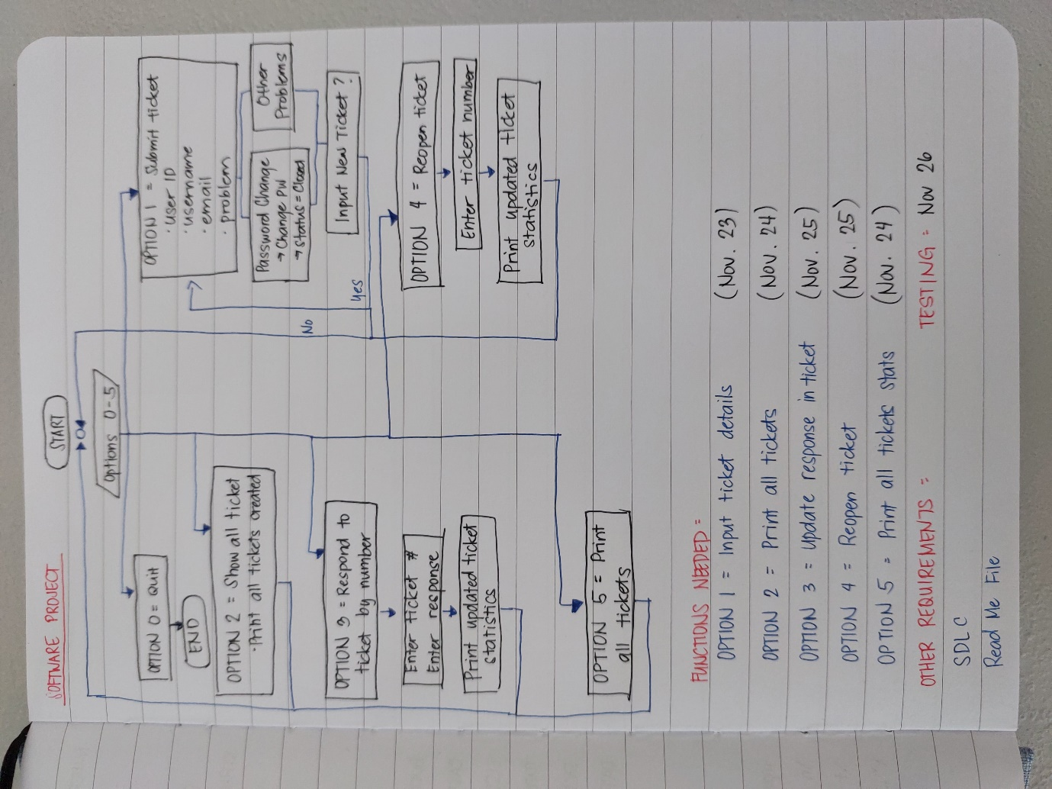

### Task 2: Requirement Analysis

At this stage, I understood the technical analysis better and identify each of them and create a plan on how I would accomplish each requirement. The technical requirement of the assignment includes input of ticket, changing password, updating the status of the ticket, reopening resolved tickets, and printing all tickets created. I was able to create a detailed plan on what each requirement should do and what output it needs to provide.



### Task 3: Solution Design

After learning about the classes in the lessons, I have planned to use classes as it will be more efficient. Although it was difficult to understand at first, it was providing a more efficient code and process. With a good understanding on how classes functions, I was able to incorporate it to the plan that I have for the software. By dividing the parts of the program into classes, it was easier for me to locate everything, and the codes became more organized and efficient.

### Task 4: Detailed Design

At this stage, I was able to plan a good layout for the functions to make it more readable and easier to comprehend. The goal is to have a design that is user-friendly and readable. I created a layout for the different parts of the program such as the opening menu, the ticket format, the ticket statistics, and the editing of specific tickets.

### Task 5: Construction

This part is the one that takes up most of the time. At this phase, I was creating the code for each function, and testing them before moving on to the next part to ensure that the part I made was working properly. Each time encounter a difficult or confusing part, I would try and search it online, or if I cannot find the answer, I would ask my husband or some friends for advice so I could understand it better. It was a challenge to understand the understand how the object-oriented programming part for the code works, but with the help of my husband, and some of our friends from the industry, and the information I got online, I was able to have a better understanding of the process and was eventually able to apply it to the software that I was creating.

### Task 6: Testing

My process mainly revolved in construction and testing. Each time I construct a part, I would test it to see if it works, before moving on to the next part. I believe that doing this made me have a better understanding of the process and to know where to find each error that I encounter. There were several errors that I encountered that it took quite some time for me to figure out.

### Task 7: Deployment

At this part, I made a detailed instructions on how the program will be used in a ReadMe file. This file will be what the user will read first in order to understand the flow of the program. I have also collated all the files into a folder and prepared it for submission.

*\*Tasks 8 and 9 doesn’t apply to the project\**